**Class Diagram**

There are total 8 diagram in our class diagram-

* Customer module
* Menu/Cart module
* Order module
* Review module
* Coin module
* Restaurant module
* Promo module
* Vat/Address module

**Customer Module**

This diagram shows class needed for customer operations and search operations. This diagram excludes order related operations of a customer.

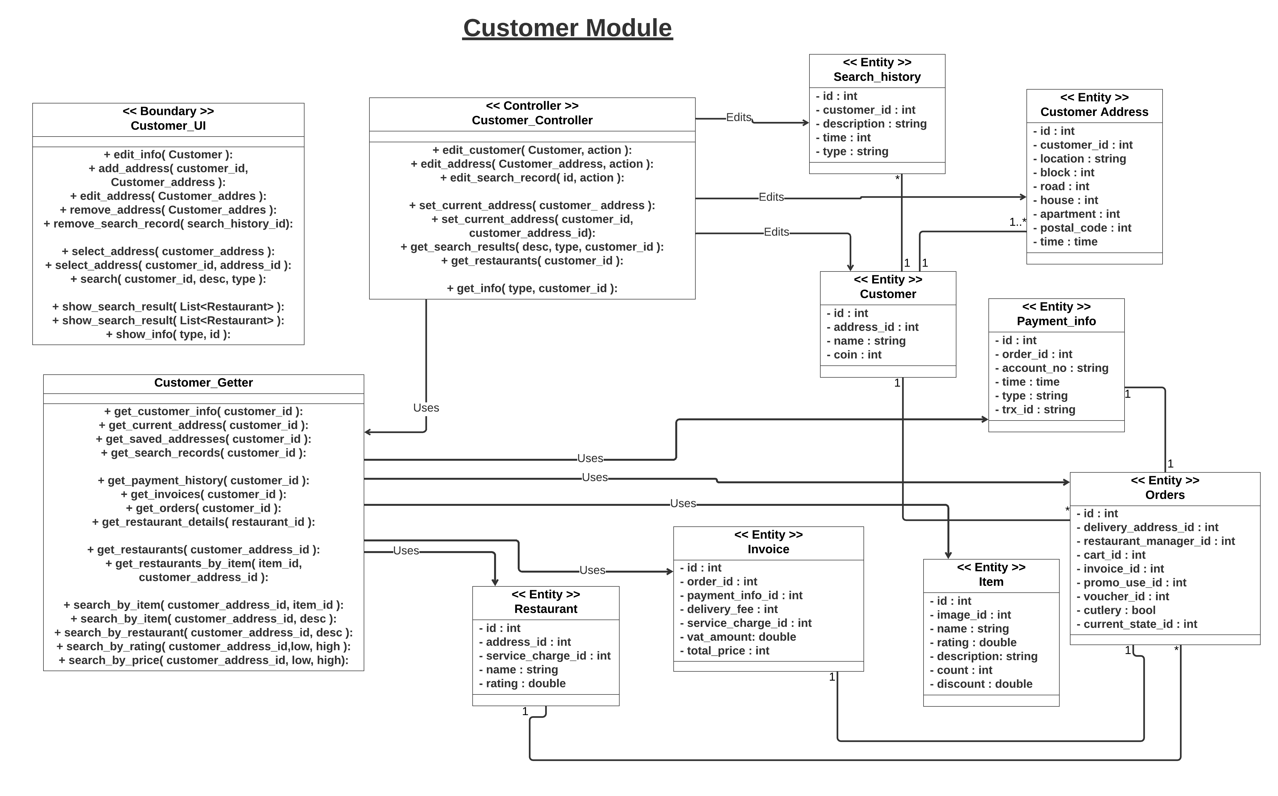

**Menu/Cart Module**

This diagram shows classes related to building up carts for orders in Customer end.

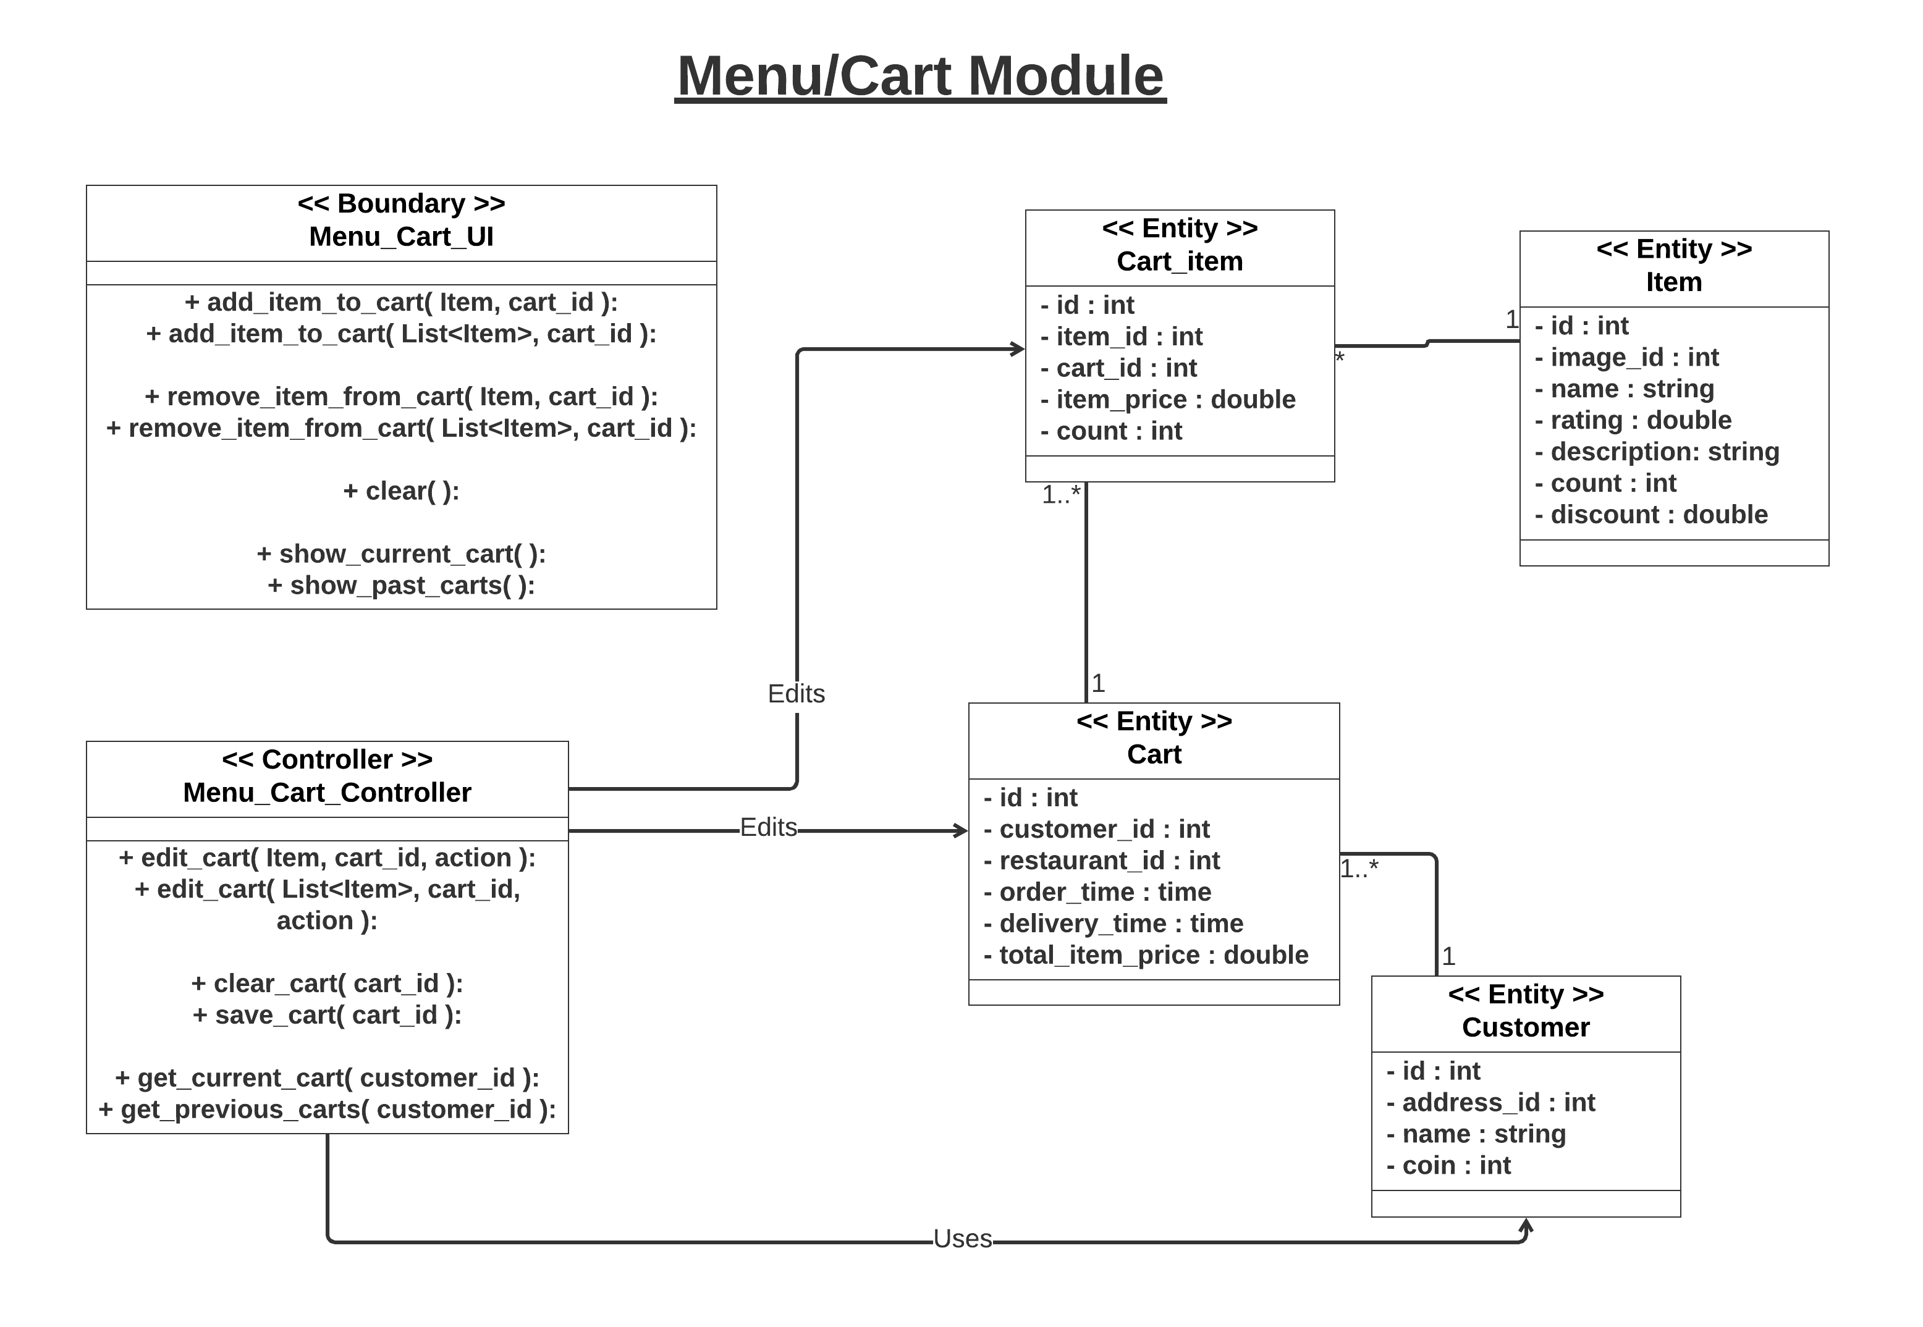

**Review Module**

This diagram shows the classes need to make a review an order from customer end, viewing order history of a restaurant from both customer and restaurant end.

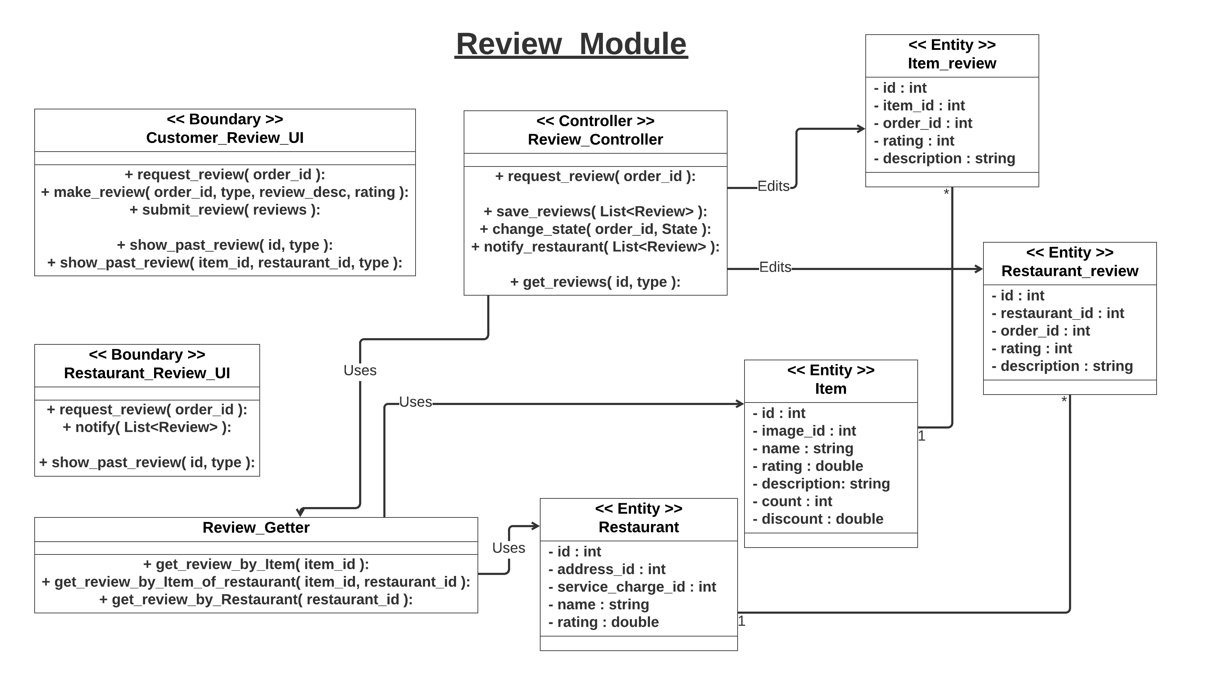

**Order Module**

This diagram shows classes related from making an order to completing the order. This considers three ends of UI: restaurant end, customer end and rider end.

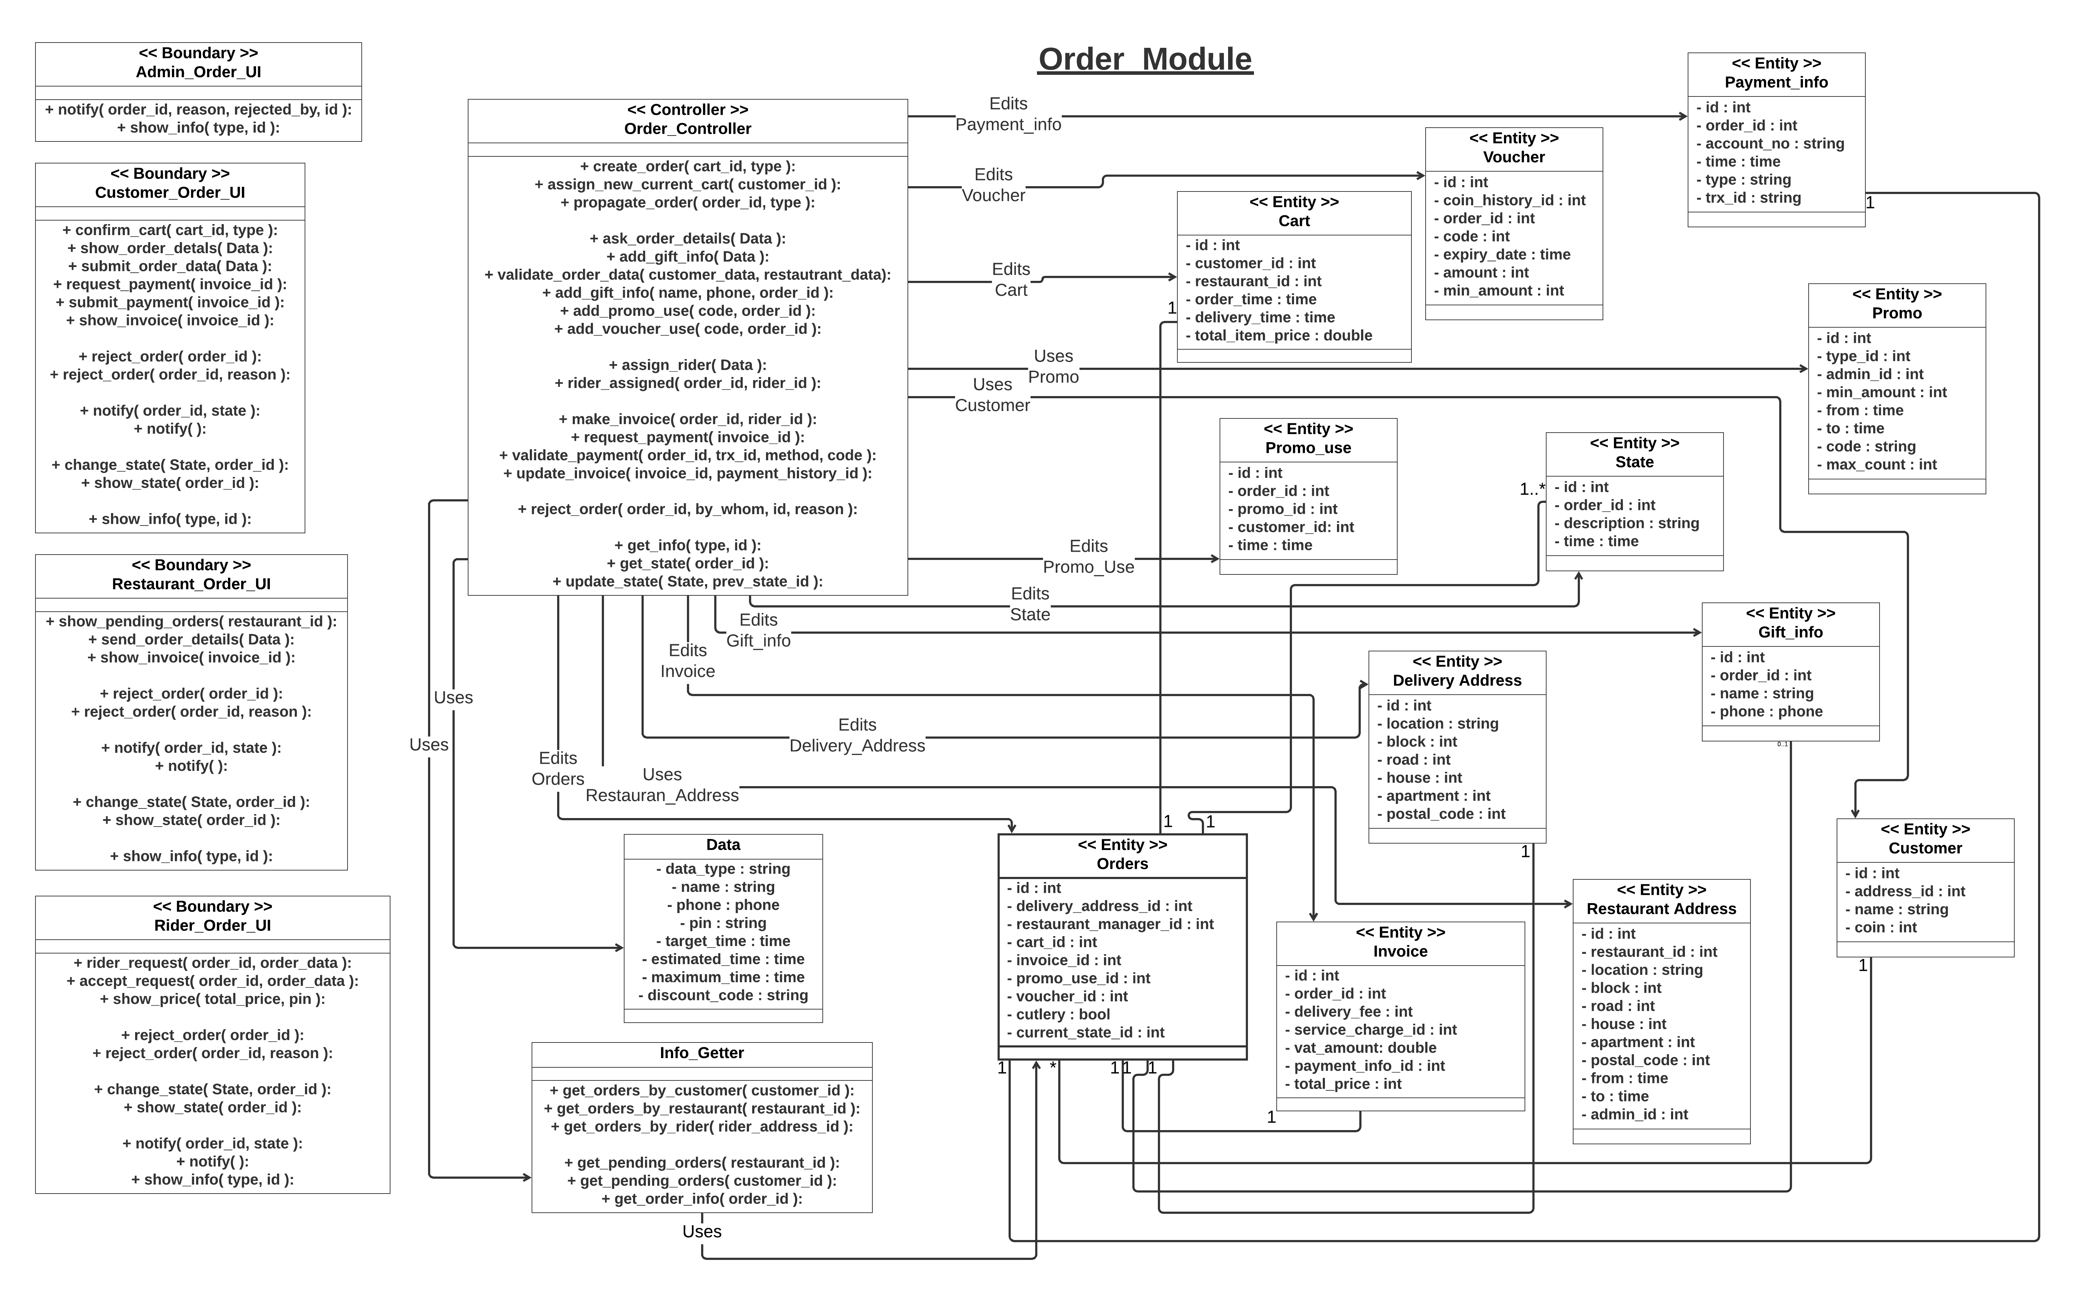

**Coin Module**

This diagram shows classes for coin module.

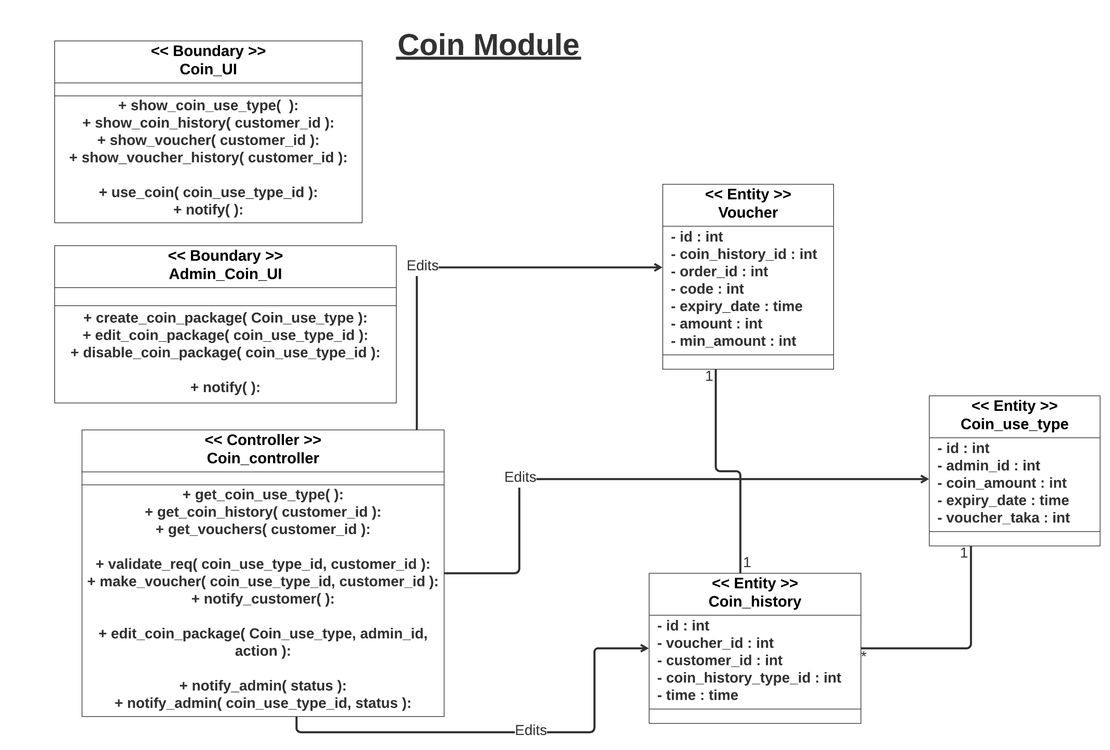

**Restaurant Module**

This diagram shows classes of all operations for the restaurant end except operations related to orders.

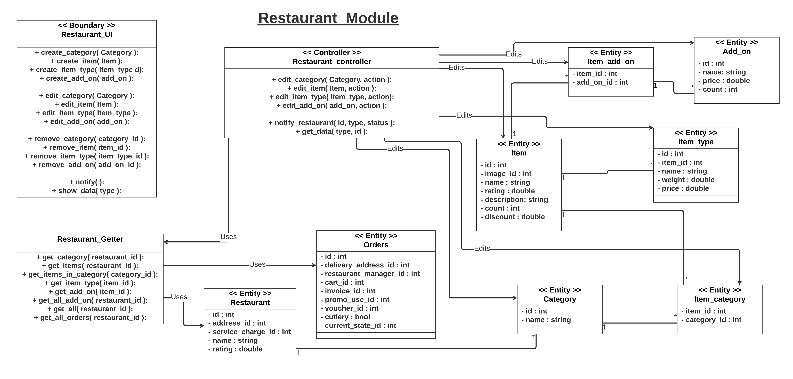

**Service Charge/Address module**

This diagram shows classes needed for restaurant end for operations related to service charge assignments or address edit operations.

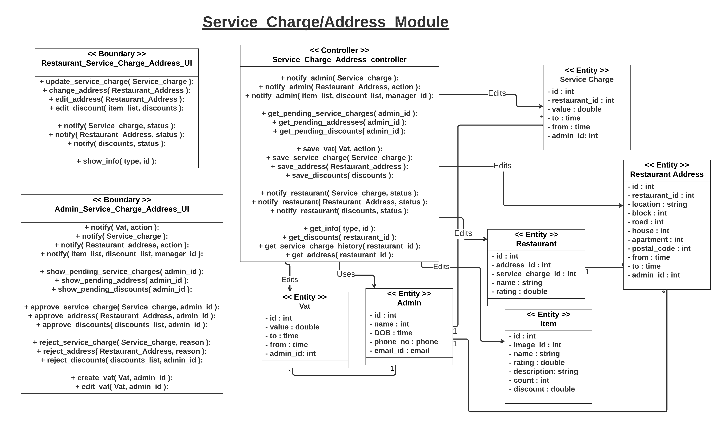

**Promo Module**

This diagram shows classes of promo module.

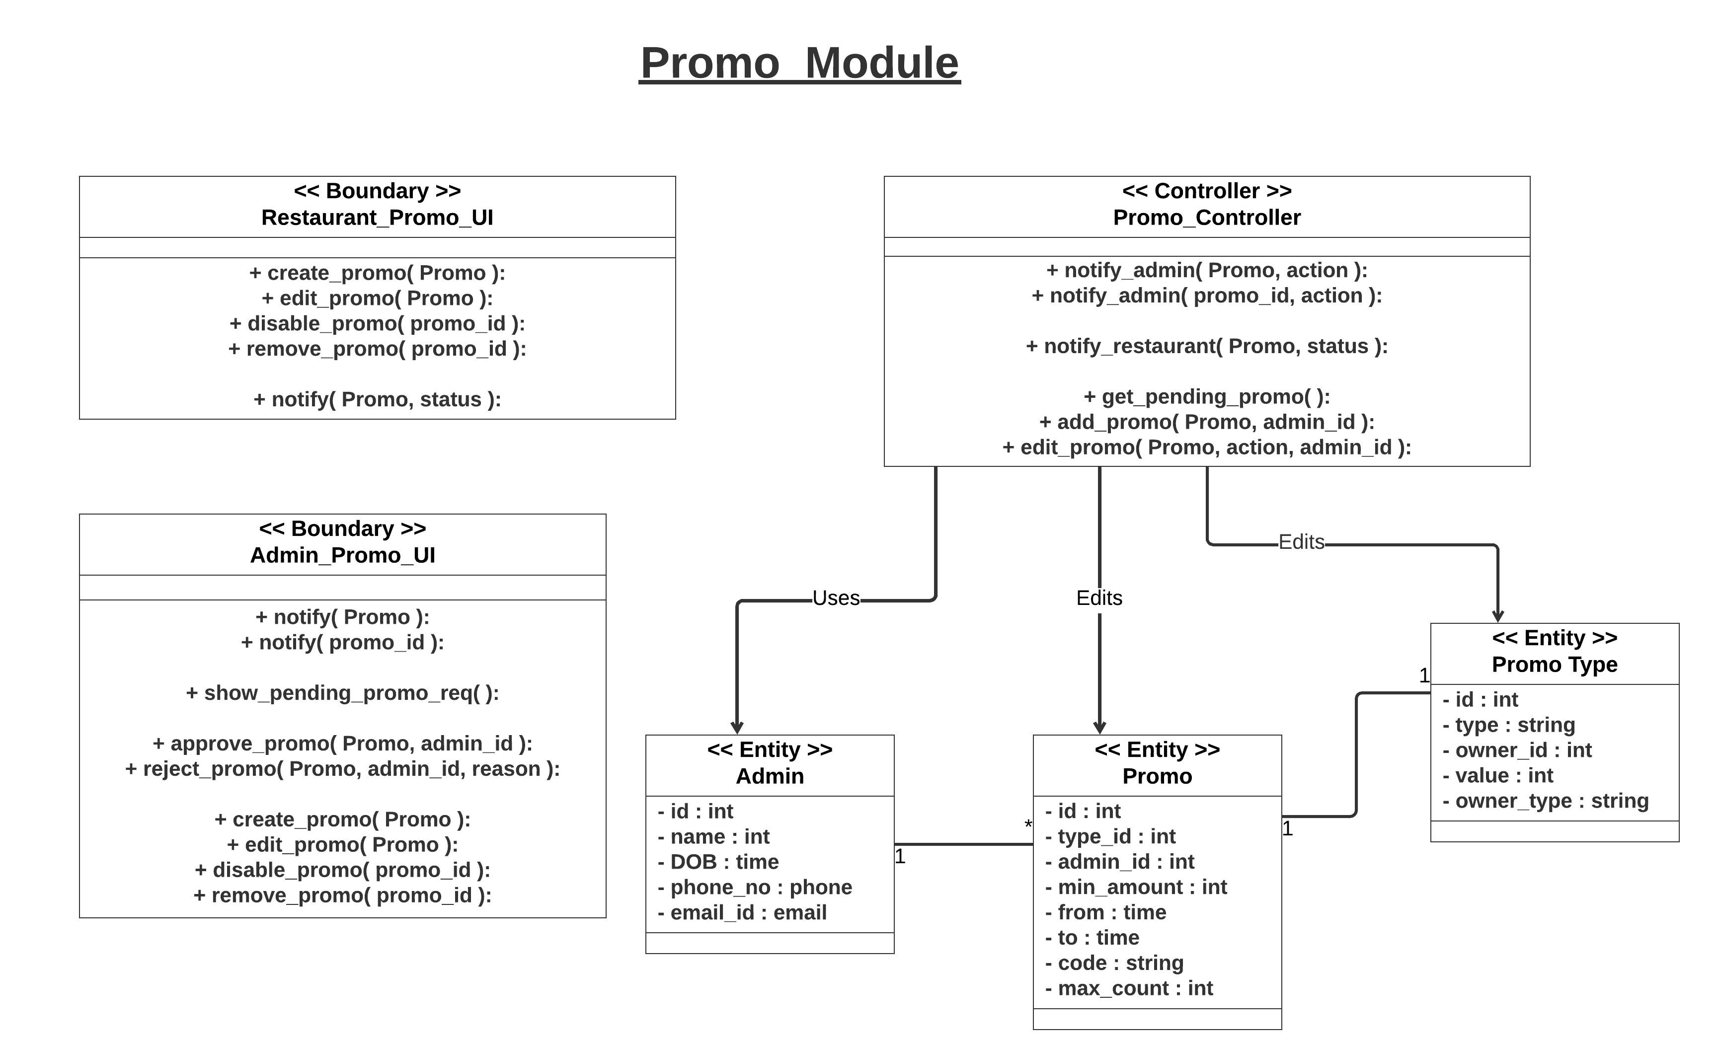

**The feedback provided in the class:**

1. We were advised to add a variable related to total price in “Cart” entity class in “Menu/Cart” module. It has been added later and named as “total_item_price”.

2. We were advised to keep a same vat for all the restaurant. It has been edited later and we added service_charge class in place of vat. The new “Vat” entity shows the change.